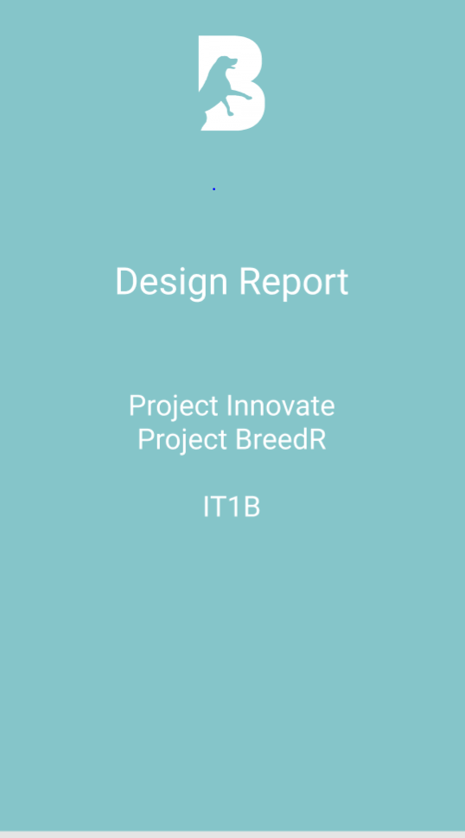

Contents

Color-Choosing 3

Style-Tile 4

Design of the Pages 5

Chat Page 5

Get Started Page 6

Profile Page 7

Registration Page 8

Settings Page 9

Swipe Page 10

Color-Choosing  
  
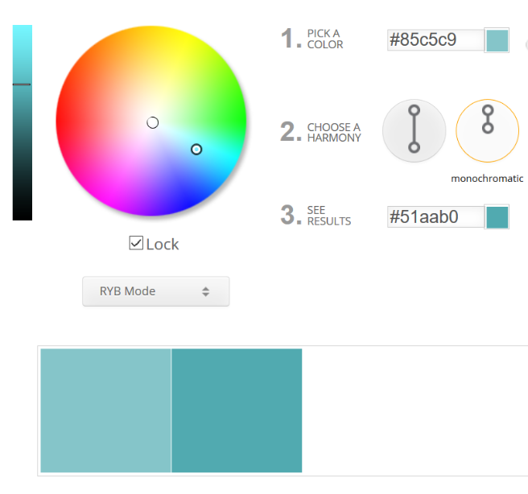

We worked with the monochromatic Color Scheme for the App. Our Goal was it to choose a clear identified color to give the customer the opportunity to recognize our Product immediately.  
  
We choose a pleasant blue for the whole scheme and worked with different shades of grey.

# Style-Tile

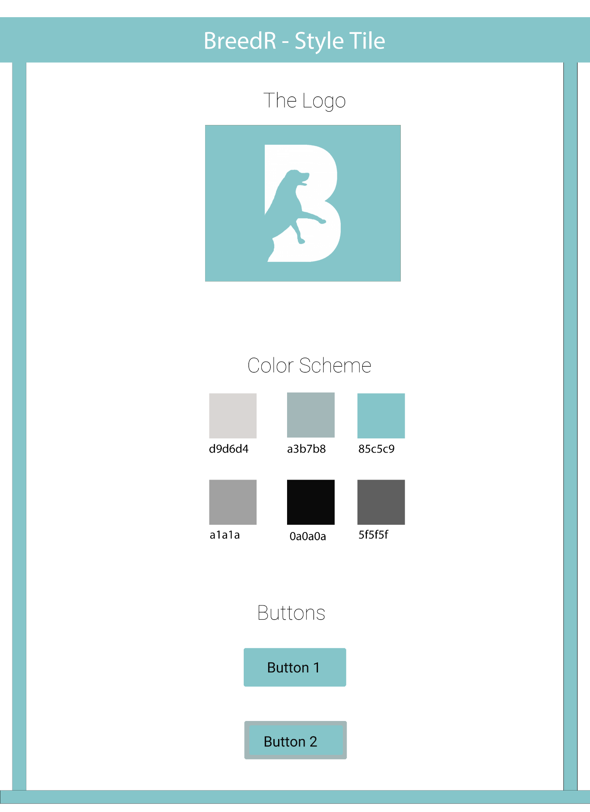

# Design of the Pages

## Chat Page

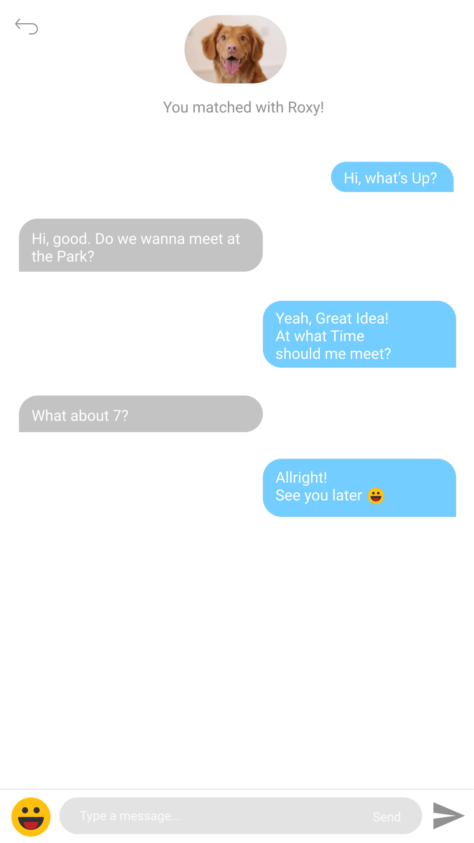

## C:\Users\Nadi\AppData\Local\Temp\Rar$DRa13068.38398\GetStarted-1.pngGet Started Page

## C:\Users\Nadi\AppData\Local\Temp\Rar$DRa2176.805\profile-1.pngProfile Page

## Registration Page

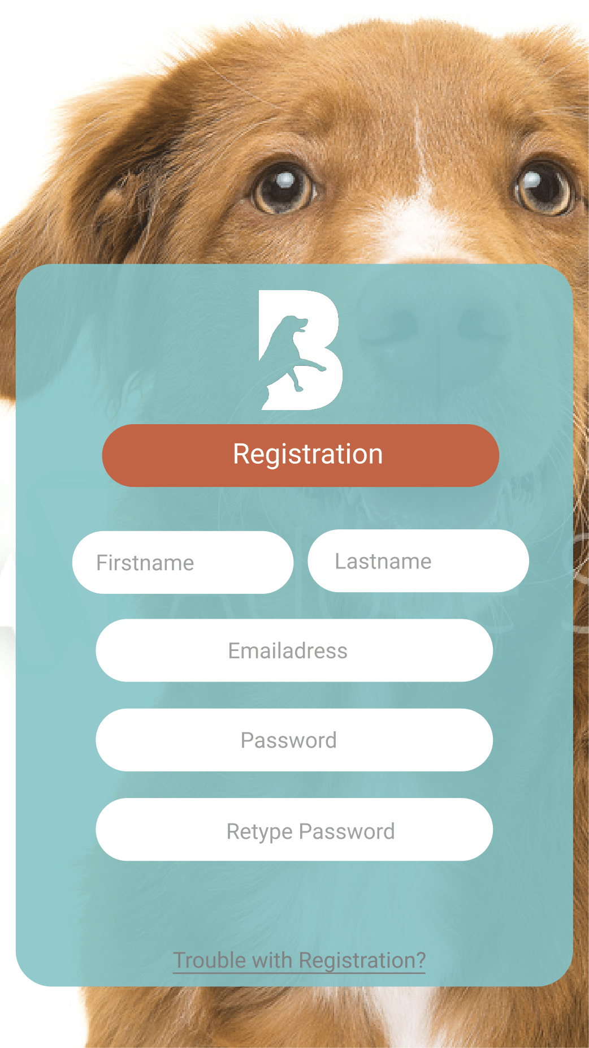

## Settings Page

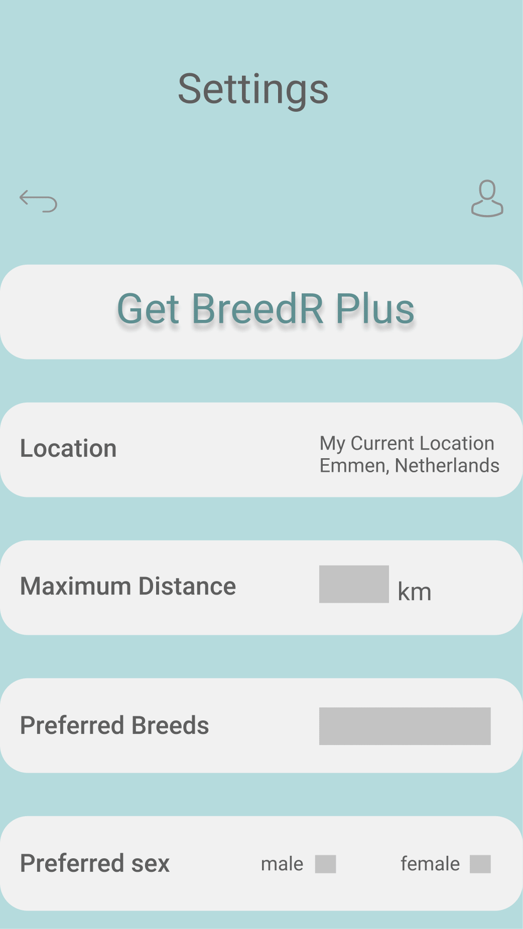

## Swipe Page